**Task 10.Use Matplotlib module for plotting in python**

**Aim:**

To use Matplotlib module for plotting in python.

**Problem 10.1. Write a Python programming to display a bar chart of the popularity of programming Languages.**

**Sample data:**  
Programming languages: Java, Python, PHP, JavaScript, C#, C++  
Popularity: 22.2, 17.6, 8.8, 8, 7.7, 6.7

**Algorithm:**

1. Define two lists for programming languages and their popularity respectively
2. Find the maximum popularity value in the list
3. Define a scaling factor to scale the bar heights within a certain limit (e.g. 50 characters)
4. For each language and popularity pair, calculate the bar height as the popularity value scaled by the scaling factor
5. Print the chart using a loop to iterate over the programming language list: a. Print the language name and a separator character (e.g. "|") b. Use a loop to print the bar chart by printing the bar character (e.g. "*") a number of times equal to the bar height c. Print the popularity value with a separator character d. Print a newline character

**Program:**

**#pip install matplotlib**

import matplotlib.pyplot as plt

languages = ['Java', 'Python', 'PHP', 'JavaScript', 'C#', 'C++']

popularity = [22.2, 17.6, 8.8, 8, 7.7, 6.7]

plt.bar(languages, popularity, color='b')

plt.title('Popularity of Programming Languages')

plt.xlabel('Programming Languages')

plt.ylabel('Popularity')

plt.show()

Output:

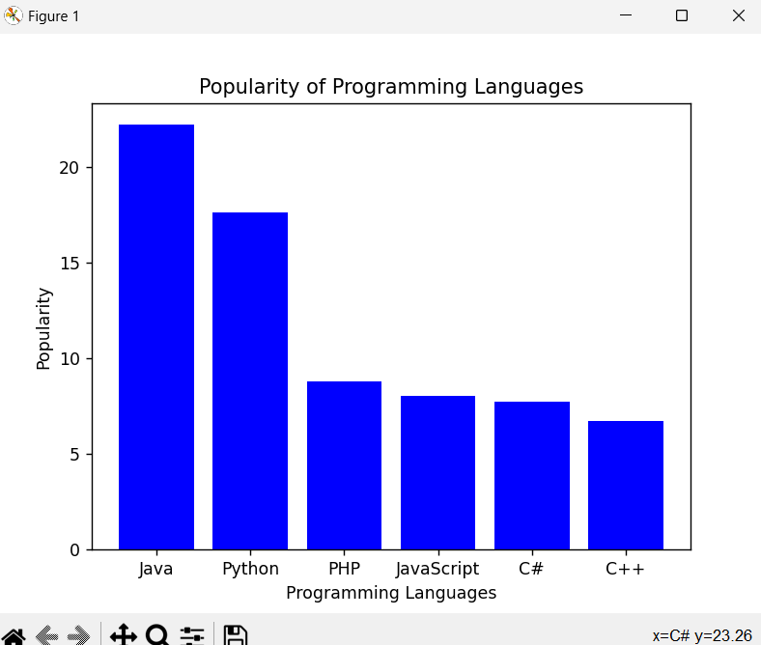

**Problem 10.2.Write a Python programming to create a pie chart of the popularity of programming Languages.**

**Sample data:**  
Programming languages: Java, Python, PHP, JavaScript, C#, C++  
Popularity: 22.2, 17.6, 8.8, 8, 7.7, 6.7

**Algorithm:**

1. Create a list of Programming Languages and Popularity
2. Create a pie chart using the matplotlib library
3. Set the title and legend for the pie chart
4. Show the pie chart

**Program:**

import matplotlib.pyplot as plt

# Step 1

languages = ['Java', 'Python', 'PHP', 'JavaScript', 'C#', 'C++']

popularity = [22.2, 17.6, 8.8, 8, 7.7, 6.7]

# Step 2

plt.pie(popularity, labels=languages, autopct='%1.1f%%')

# Step 3

plt.title('Popularity of Programming Languages')

plt.legend(languages, loc="best")

# Step 4

plt.show()

Output:

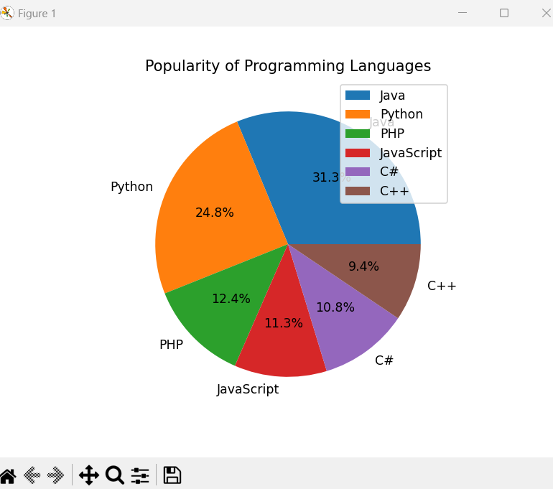

**Problem 10.3. Write a Python programming to create a line graph showing marks of each student across all 4 tests.**

**Sample data:**

**Students.csv**  
Name,Test1,Test2,Test3,Test4

Alice,75,80,78,90

Bob,88,85,82,87

Charlie,60,65,70,68

David,92,95,90,94

Eva,70,72,75,78

**Algorithm:**

1. **Import libraries:**

pandas for reading CSV data.

matplotlib.pyplot for plotting.

1. **Read CSV file** using pd.read_csv("students.csv").
2. **Extract student names** from the "Name" column for the x-axis.
3. **Plot each test’s marks** as a separate line on the graph:

Use marker='s' for Test1, marker='o' for Test2, etc.

Use label parameter to name each line.

1. **Add labels, title, and legend:**

plt.ylabel("Marks")

plt.title("Student Marks Across Tests")

plt.legend()

1. **Display the plot** using plt.show().

**Program:**

import pandas as pd

import matplotlib.pyplot as plt

# Read CSV

df = pd.read_csv("students.csv")

# x-axis = student names

x = df["Name"]

# Plot each test as a separate line

plt.plot(x, df["Test1"], marker='s', label="Test1")

plt.plot(x, df["Test2"], marker='o', label="Test2")

plt.plot(x, df["Test3"], marker='*', label="Test3")

plt.plot(x, df["Test4"], marker='x', label="Test4")

plt.ylabel("Marks")

plt.title("Student Marks Across Tests")

plt.legend()

plt.show()

**Output:**

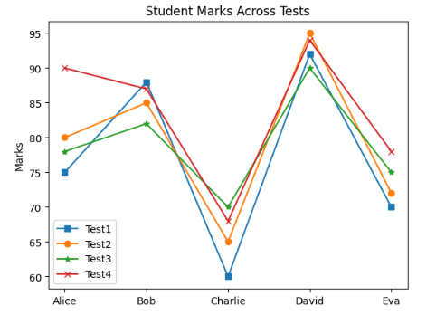

**Result:** Thus the python program use Matplotlib module for plotting is executed and verified successfully.